**DAILY ONLINE ACTIVITIES SUMMARY**

|  |  |  |  |  |  |  |  |
| --- | --- | --- | --- | --- | --- | --- | --- |
| **Date:** | **07-07-2020** | | | | **Name:** | **B.A.SOHANKUMAR** | |
| **Sem & Sec** | **4th SEM A** | | | | **USN:** | **4AL18CS013** | |
| **Online Test Summary** | | | | | | | |
| **Subject** | | **----** | | | | | |
| **Max. Marks** | | **----** | | **Score** | | **----** | |
| **Certification Course Summary** | | | | | | | |
| **Course** | **INTRODUCTION TO ADVANCED SPARK** | | | | | | |
| **Certificate Provider** | | | **GLA** | **Duration** | | | **1.5 HOUR** |
| **Coding Challenges** | | | | | | | |
| **Problem Statement:1:Write a Java program to find the length of loop in linked list.** | | | | | | | |
| **Status: EXECUTED** | | | | | | | |
| **Uploaded the report in Github** | | | | **YES** | | | |
| **If yes Repository name** | | | | **https://github.com/sohannaik5648987/DAILY-REPORTS** | | | |
| **Uploaded the report in slack** | | | | **YES** | | | |

**ONLINE CERTIFICATION COURSE**:

Course: Introduction to advanced spark

Today I have opted this new course and this course has the video content of 1.5 hours and completed modules today are Configure the Spark,Spark properties,Performance tuning,Data serialization,Memory tuning,Garbage collection,Memory usage and levels of parallelism,Data locality and broadcasting,Job scheduling,Modes in cluster management,Dynamic resource allocation,Decommission of executors,Application schedule,Apache Spark and completed the course.

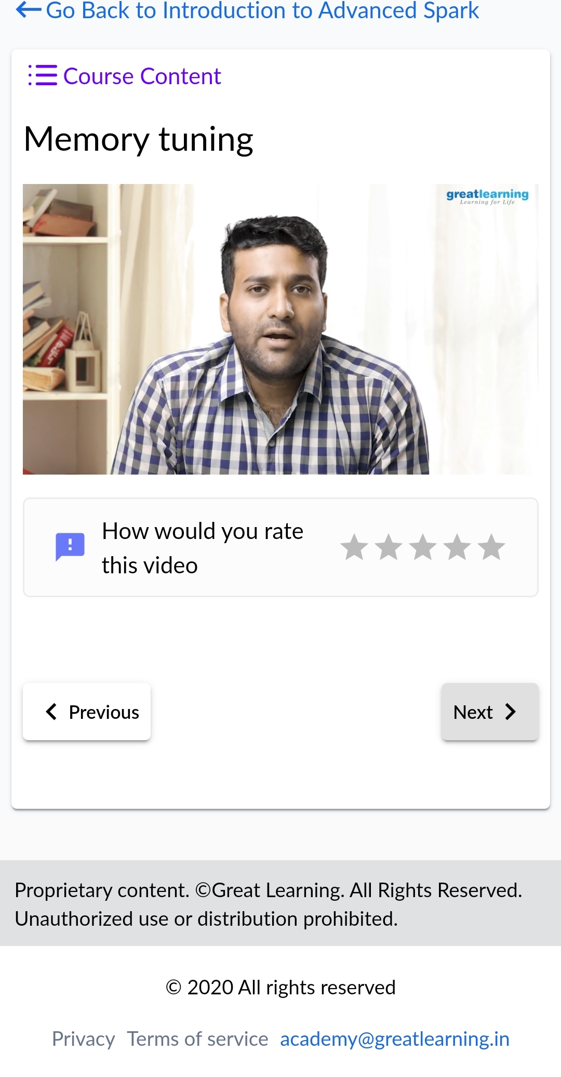 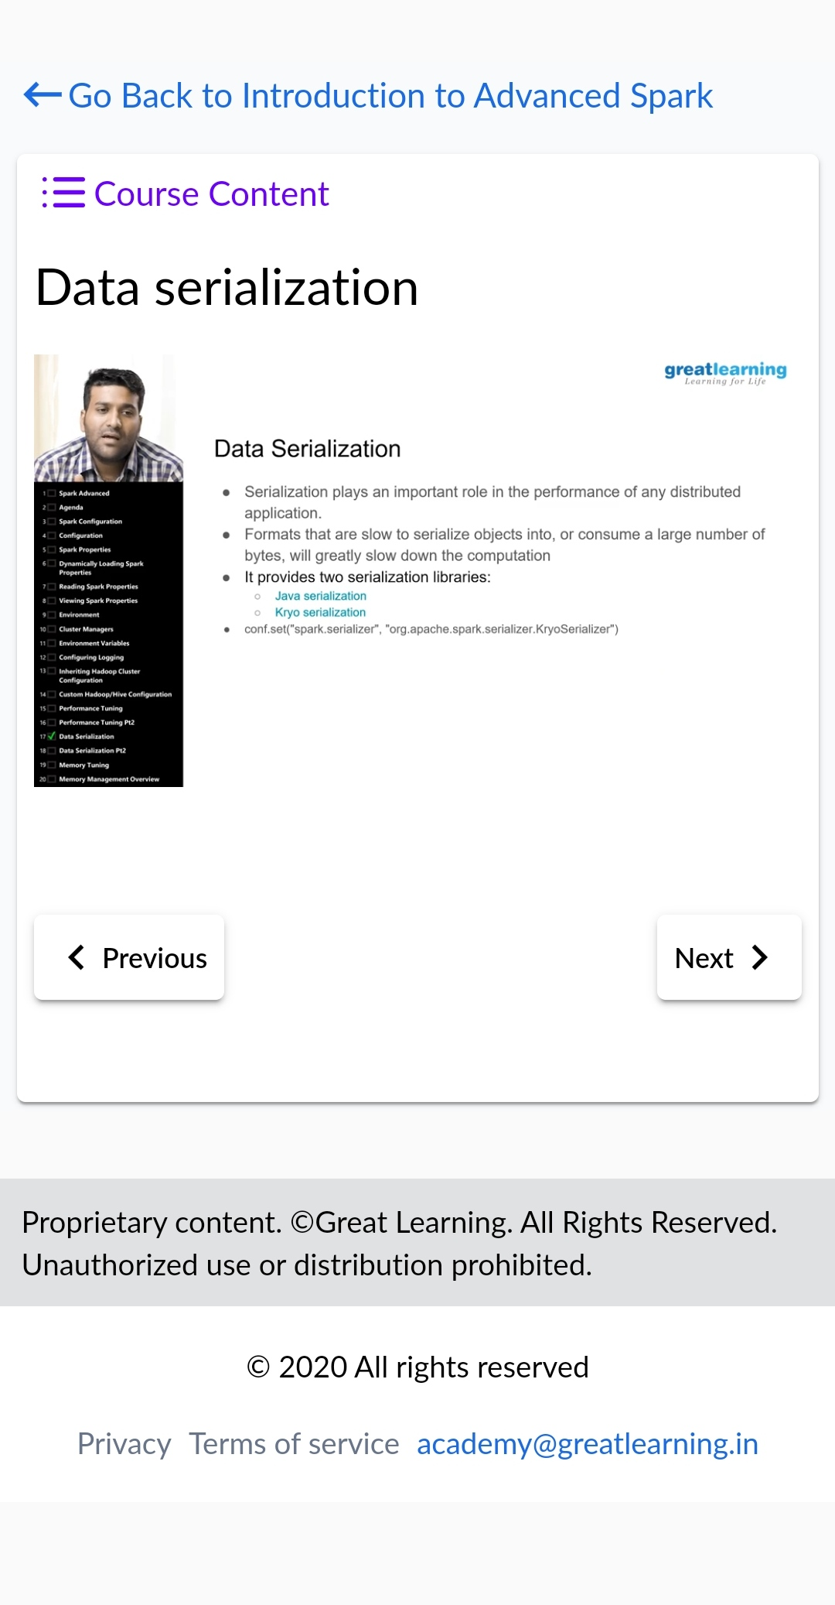

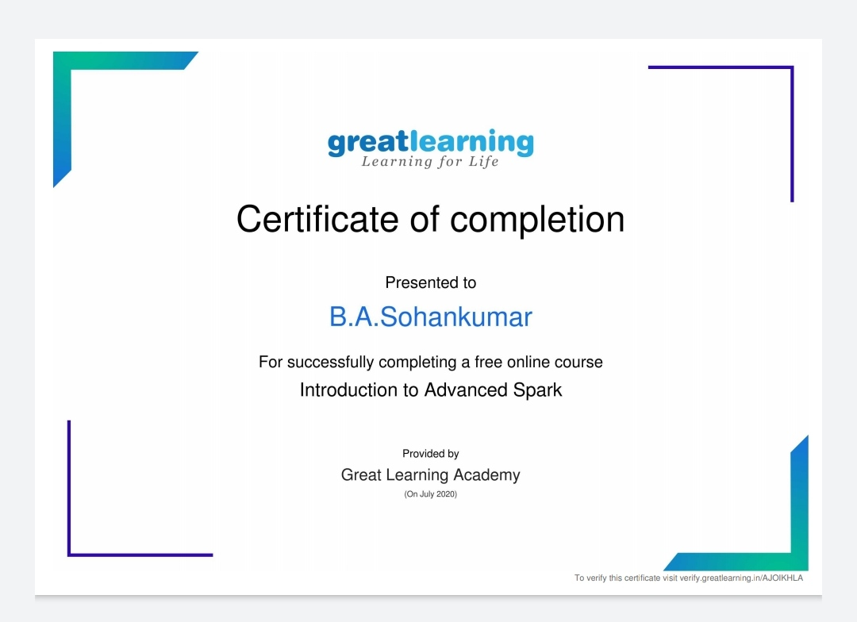

Above certificate is awarded for the completion of this course.

**CODING CHALLENGES:**

1.Write a Java program to find the length of loop in linked list.

1. 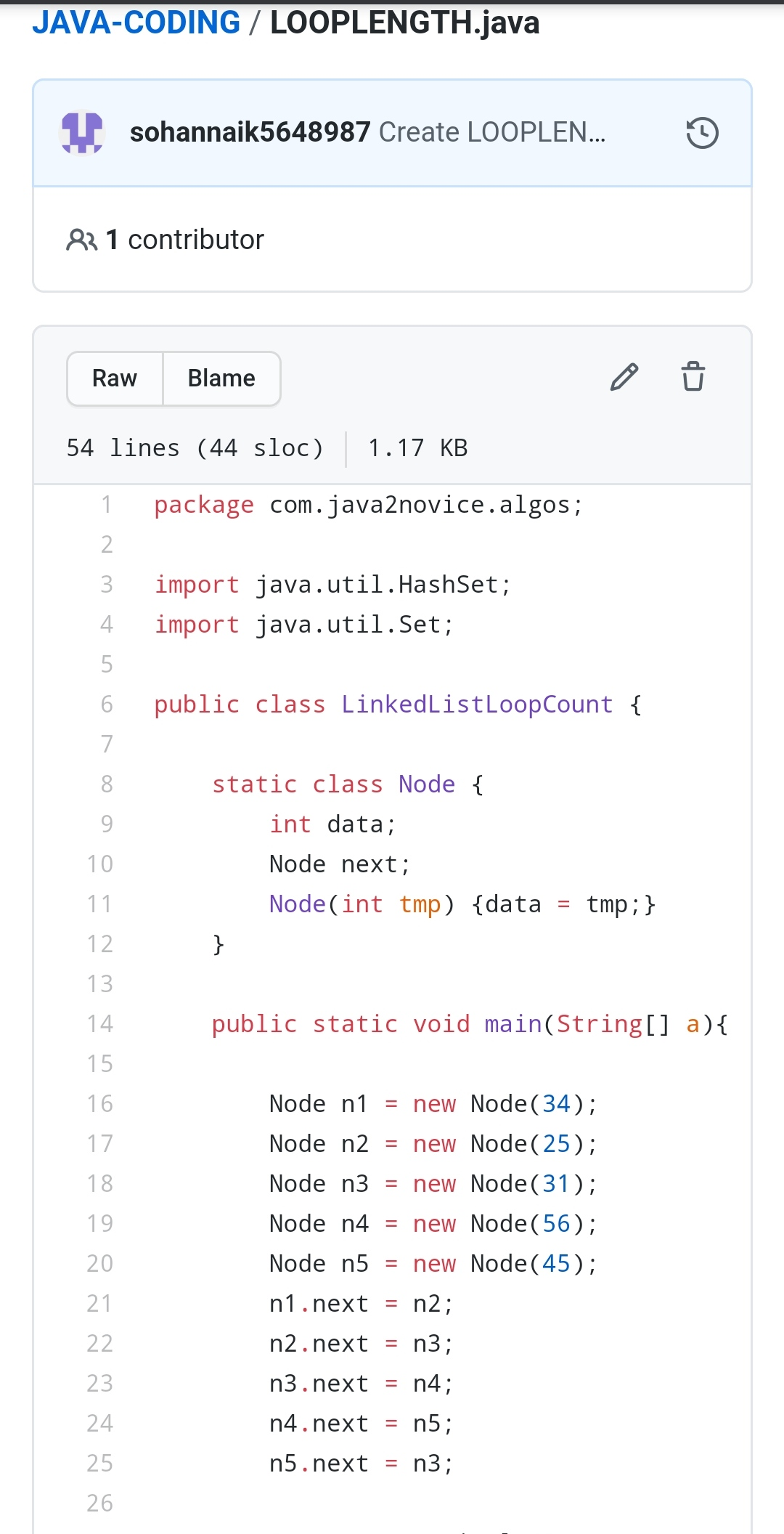

REPOSITORY LINK:https://github.com/sohannaik5648987/JAVA-CODING